PRACTICAL OF ARTIFICIAL INTELLIGENCE
RAMANUJAN COLLEGE



UNIVERSITY OF DELHI
SEMESTER- 3
(2025-26)
SUBMITTED TO-
MS. BHAVYA AHUJA
DEPARTMENT OF COMPUTER SCIENCE
RAMANUJAN COLLEGE
UNIVERSITY OF DELHI, KALKAJI NEW DELHI-110019

SUBMITTED BY
TANISHA KANOJIA
24570068
(24020570049)

1.Write a PROLOG program to implement the family tree and demonstrate the family
relationship.
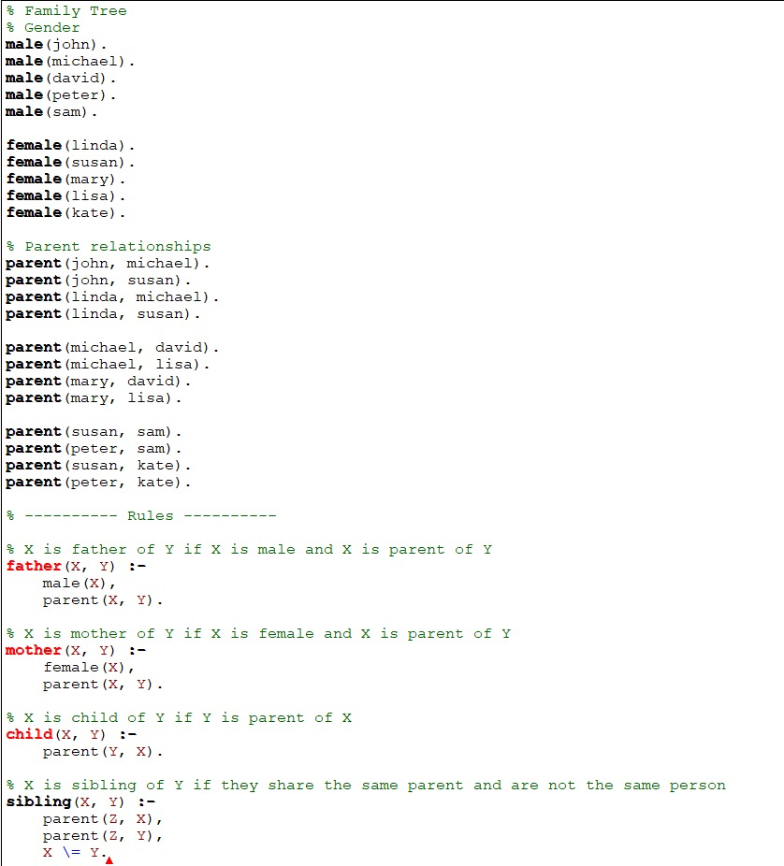
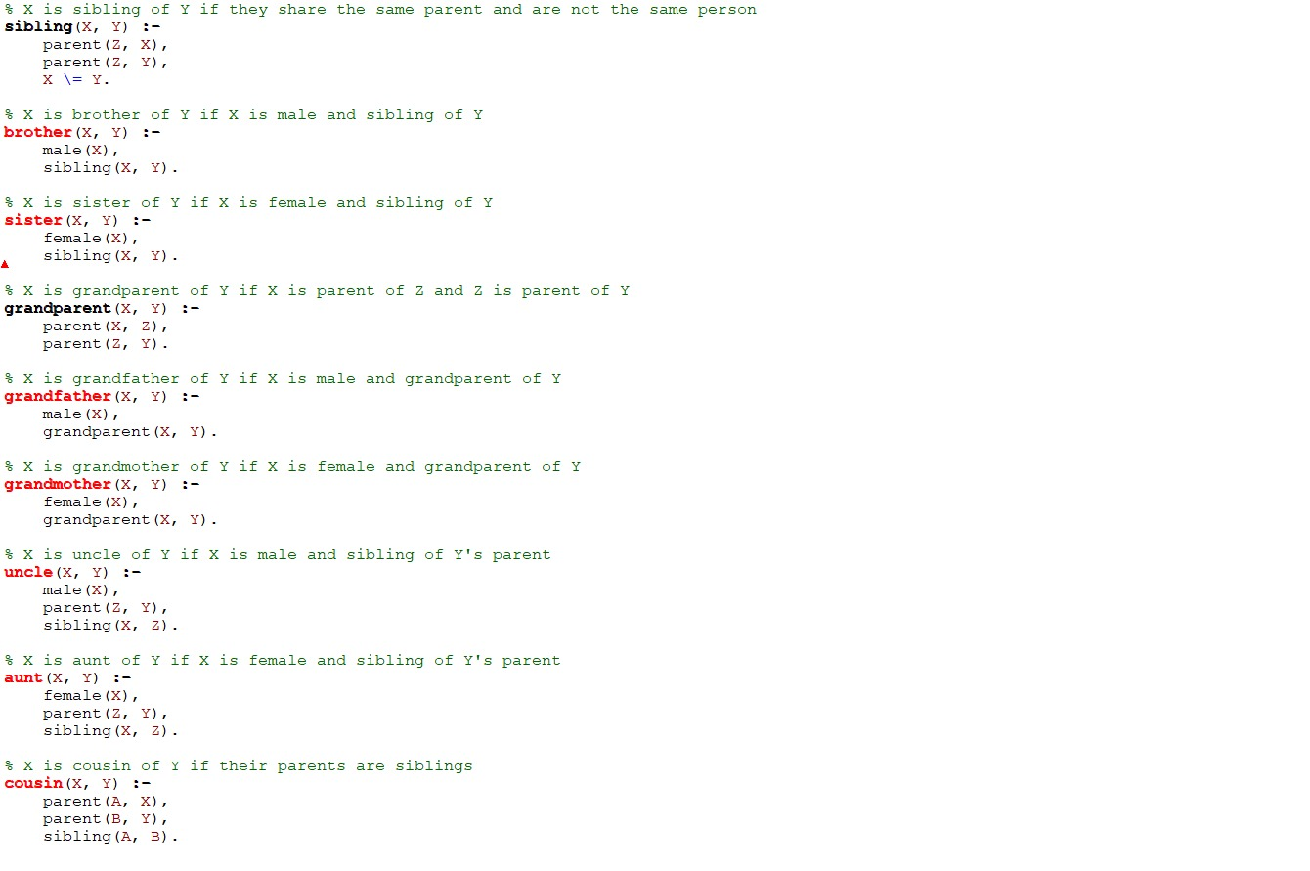
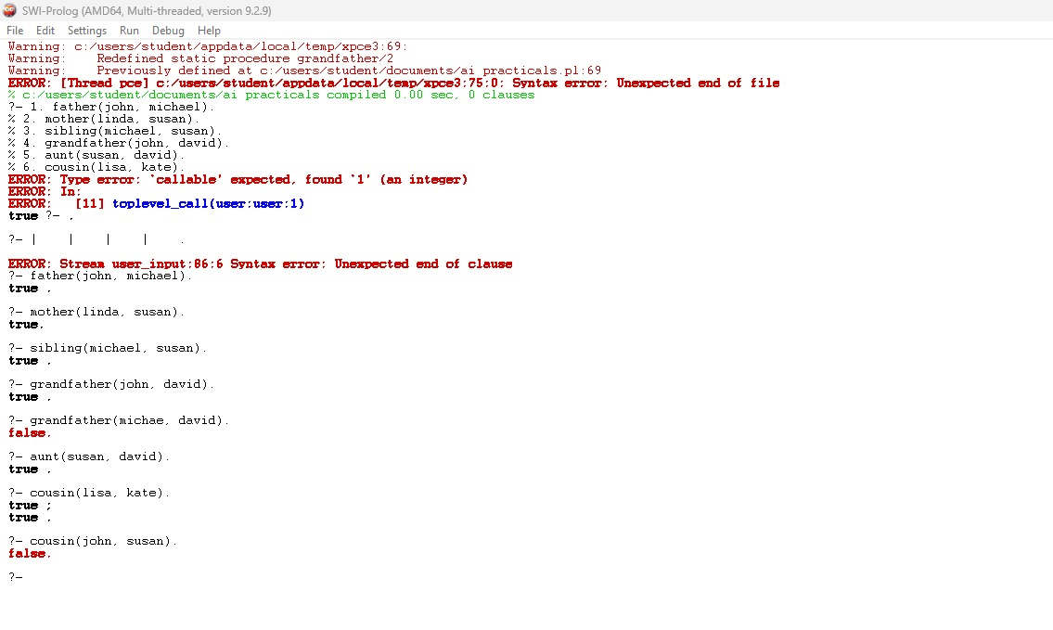

2. Write a PROLOG program to implement conc(L1, L2, L3) where L2 is the list to be
appended with L1 to get the resulted list L3.
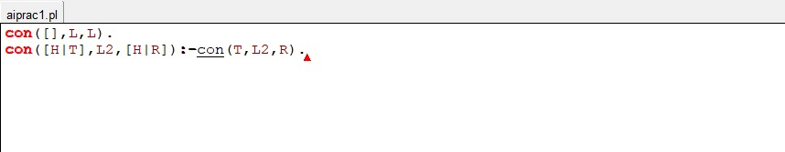
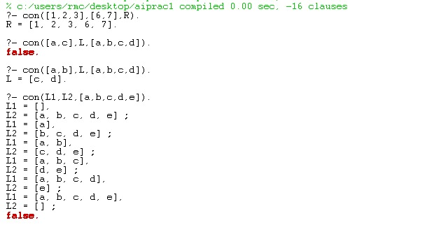

3. Write a PROLOG program to implement reverse(L, R) where List L is original and List
R is reversed list.
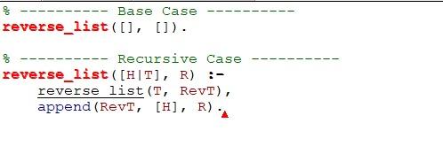
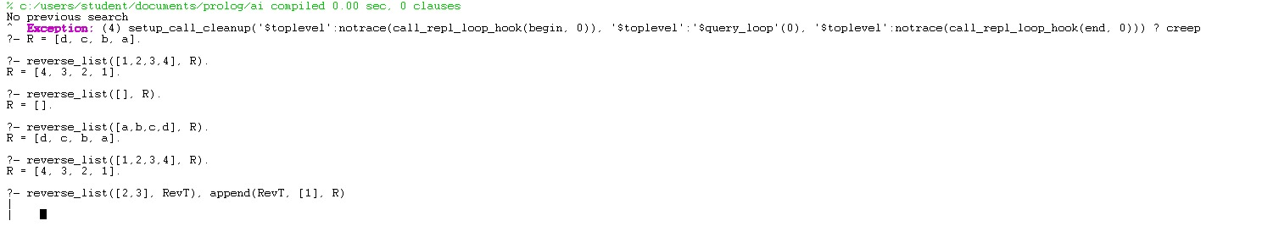

4. Write a PROLOG program to calculate the sum of two numbers.
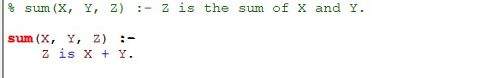
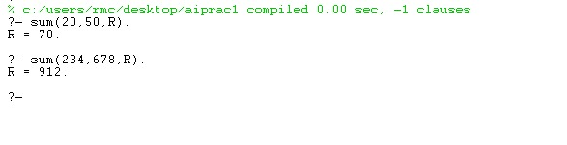

5. Write a PROLOG program to implement max(X, Y, M) so that M is the maximum of
two numbers X and Y.
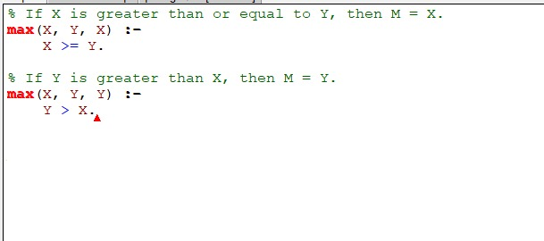
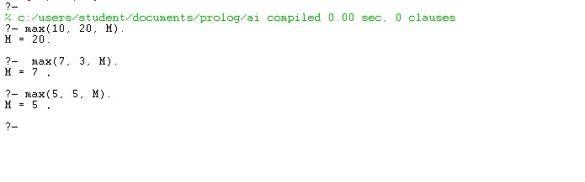

6. Write a program in PROLOG to implement factorial (N, F) where F represents the
factorial of a number N.
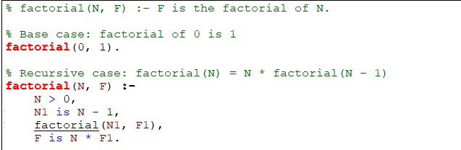
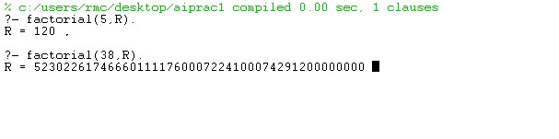

7. Write a program in PROLOG to implement generate_fib(N,T) where T represents the
Nth term of the Fibonacci series.
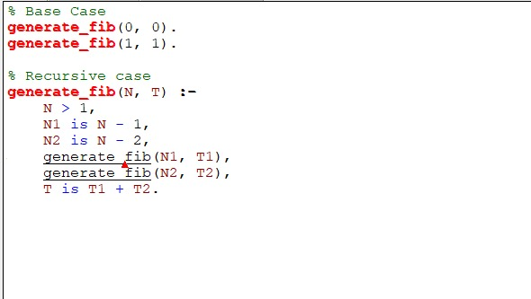
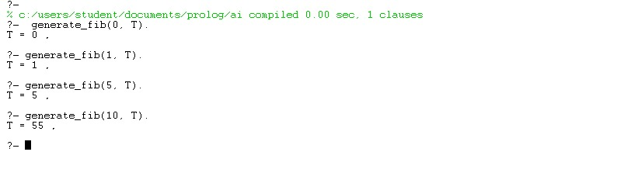

8. Write a PROLOG program to implement power (Num, Pow, Ans) : where Num is
raised to the power Pow to get Ans.
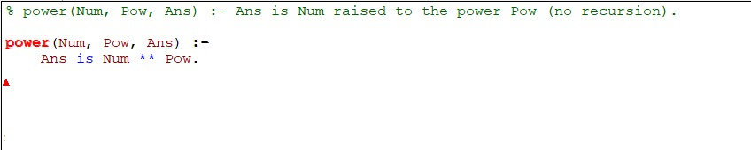

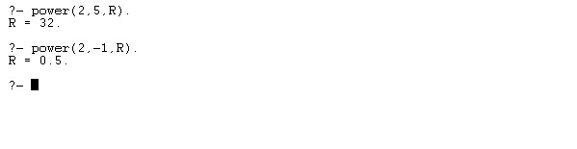

9. PROLOG program to implement multi (N1, N2, R) : where N1 and N2 denotes the
numbers to be multiplied and R represents the result.
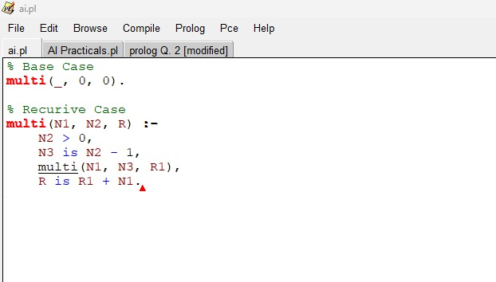
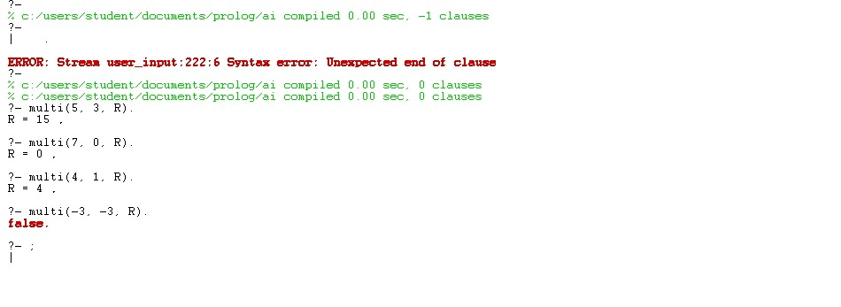

10. Write a PROLOG program to implement memb(X, L): to check whether X is a member
of L or not.
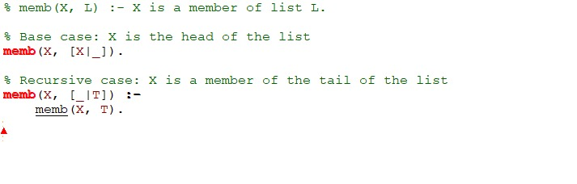
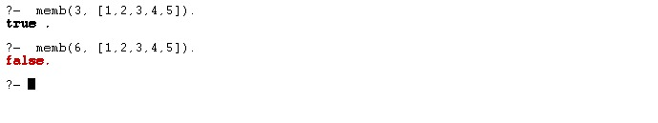

11. Write a PROLOG program to implement sumlist(L, S) so that S is the sum of a given
list L.
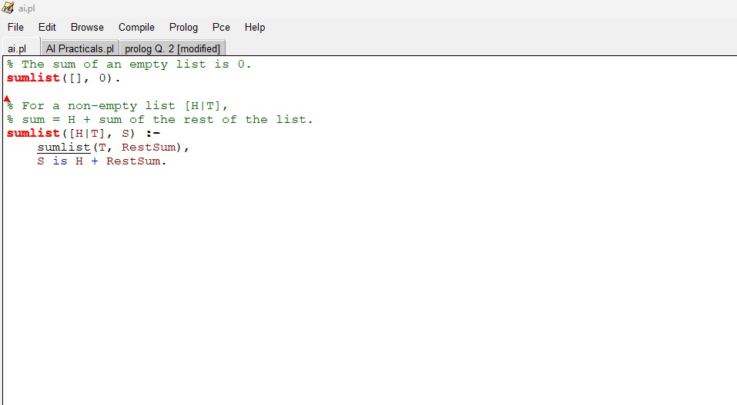
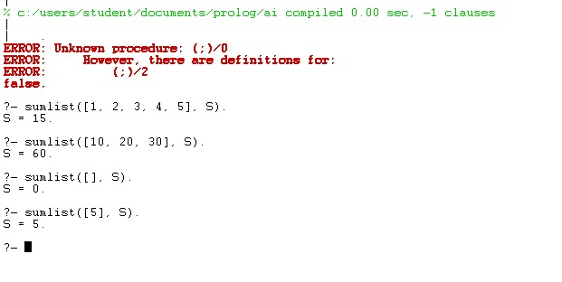

12. Write a PROLOG program to implement two predicates evenlength(List) and
oddlength(List) so that they are true if their argument is a list of even or odd length
respectively.
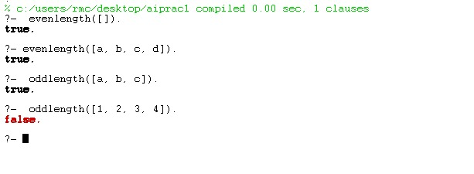
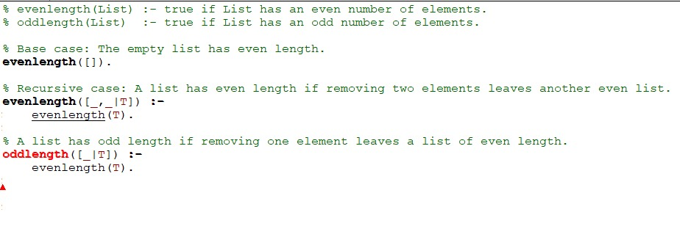

13. Write a PROLOG program to implement maxlist(L, M) so that M is the maximum
number in the list.
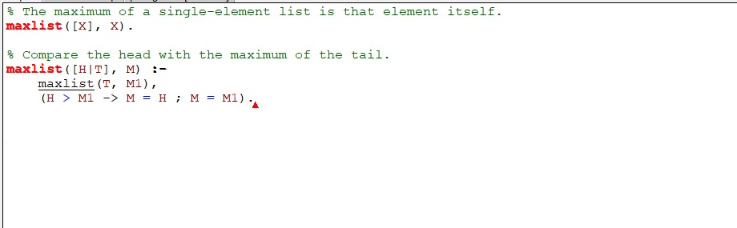
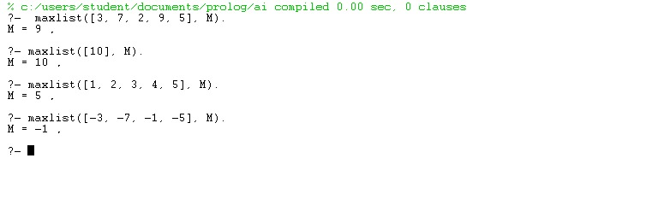

14. Write a PROLOG program to implement insert(I, N, L, R) that inserts an item I into
Nth position of list L to generate a list R.
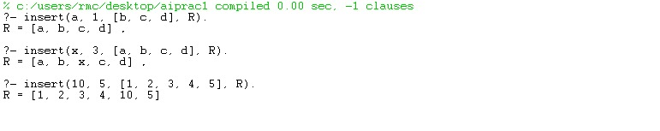
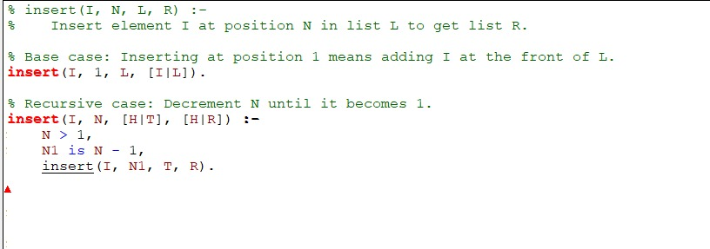

15. Write a PROLOG program to implement delete(N, L, R) that removes the element on
Nth position from a list L to generate a list R.
